**Disaster analysis Using Tableau**

**Declared Country in North America by State**

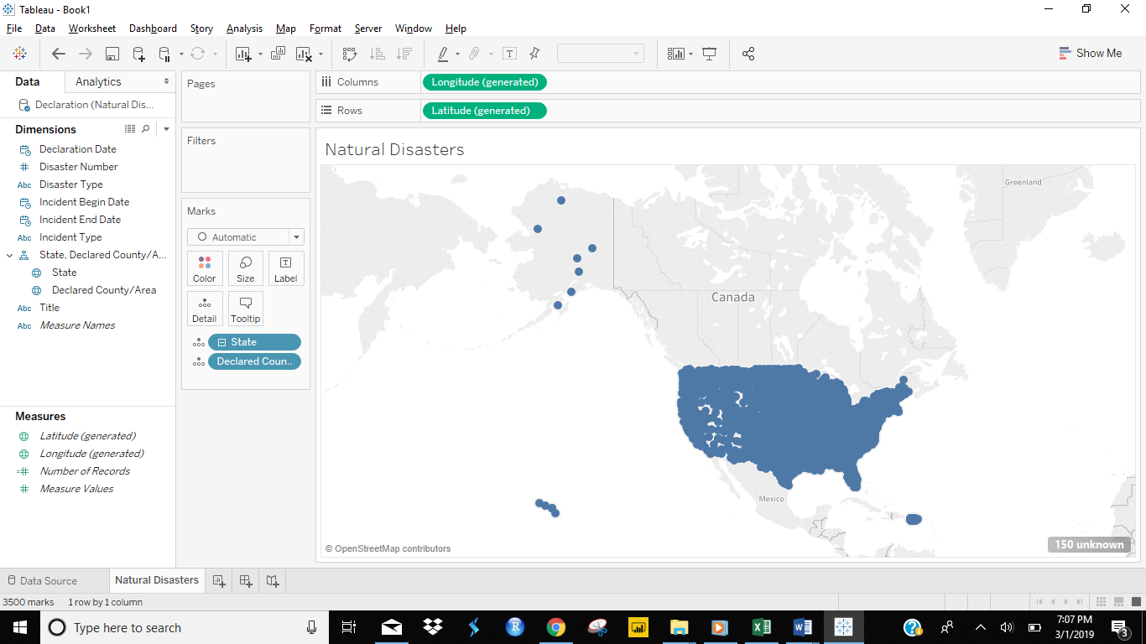

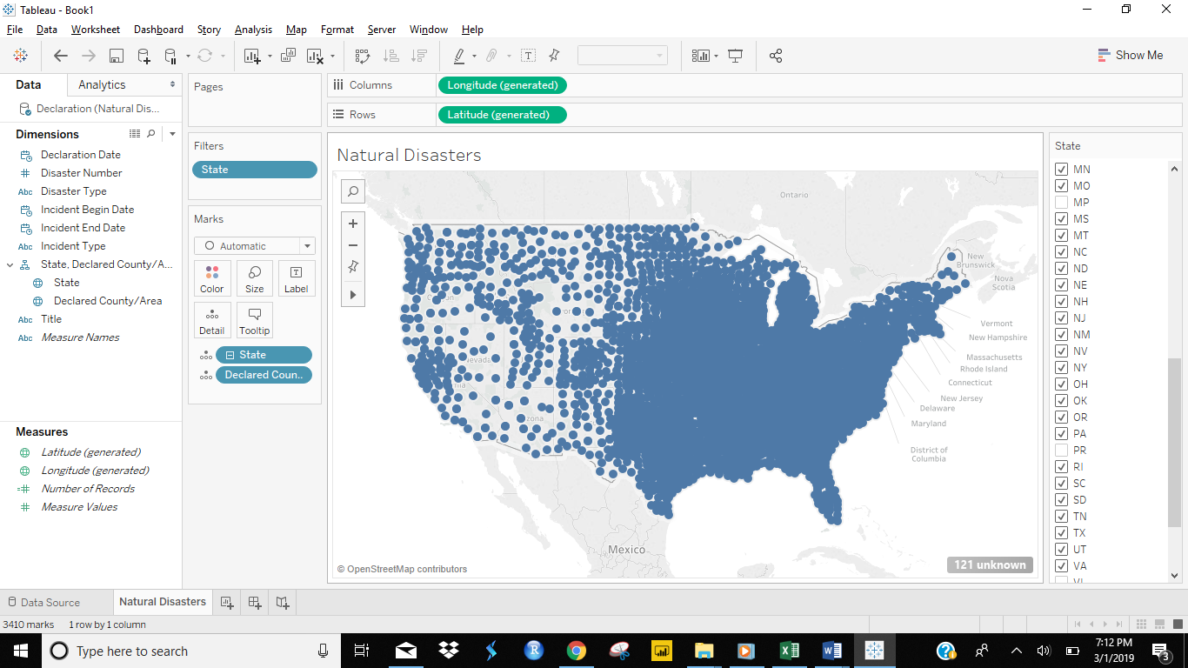

**Incident Type and Declared Country in North America by State**

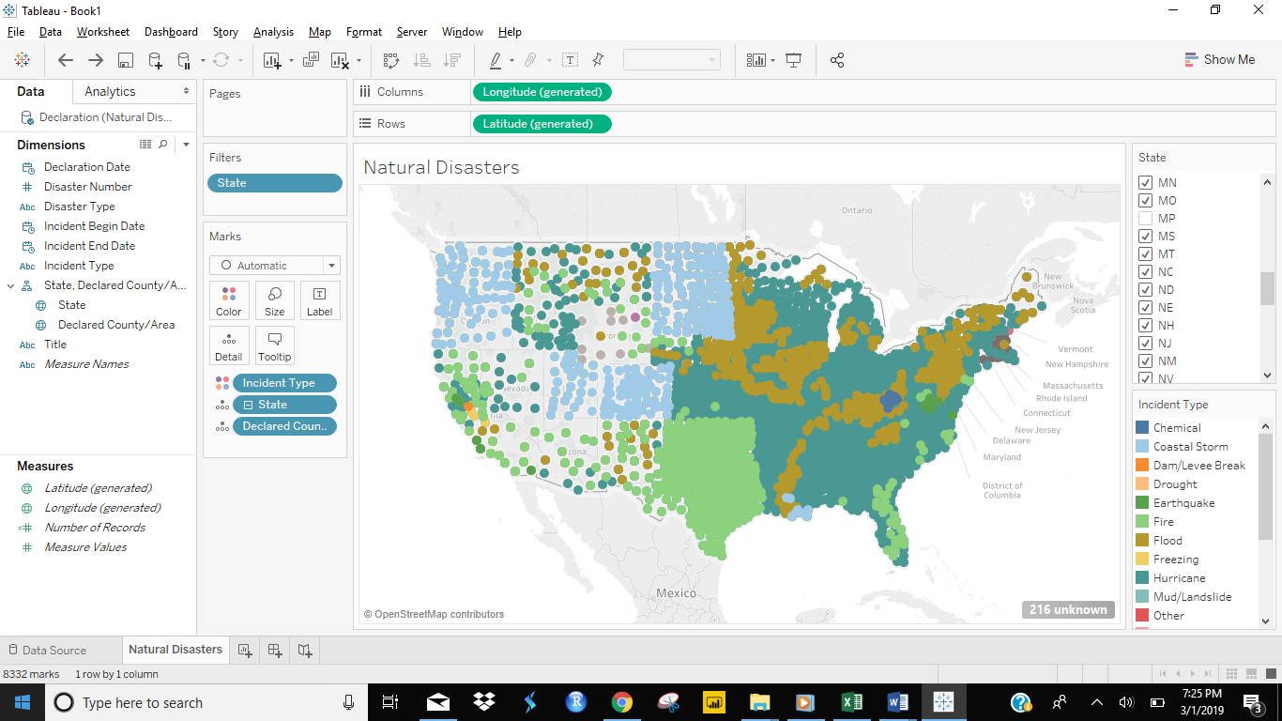

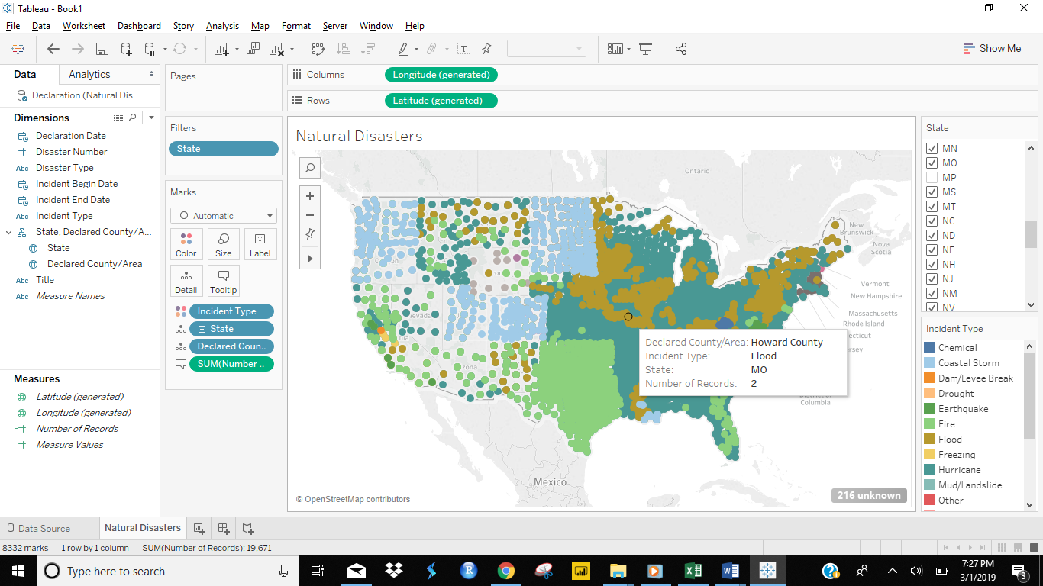

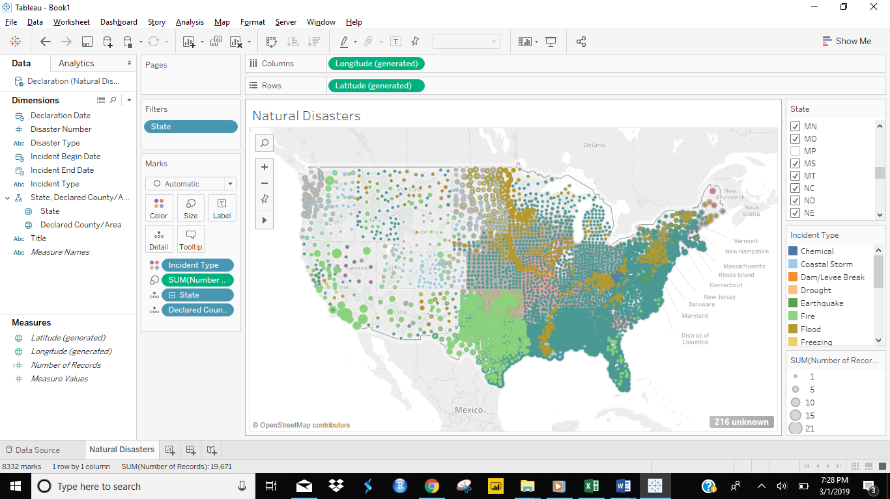

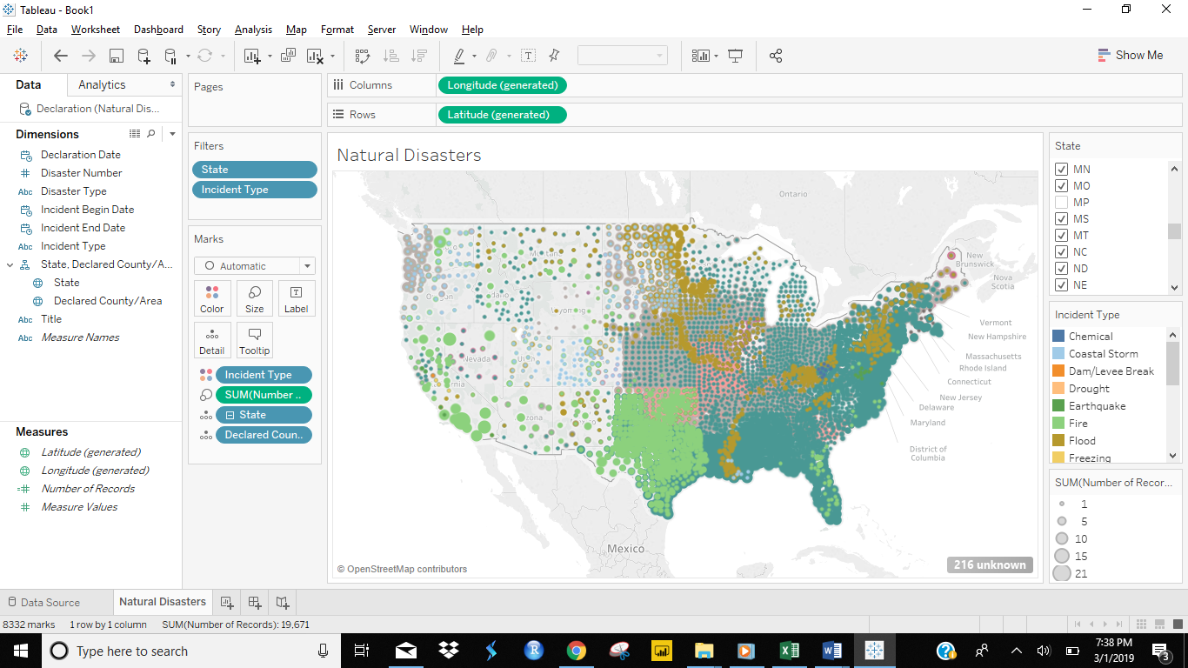

Inference from above figures - As per your map Alabama - Hurricane is the most prevalent disaster in Texas and Alabama?

The below map which is the most prevalent disaster in Texas: Hurricane

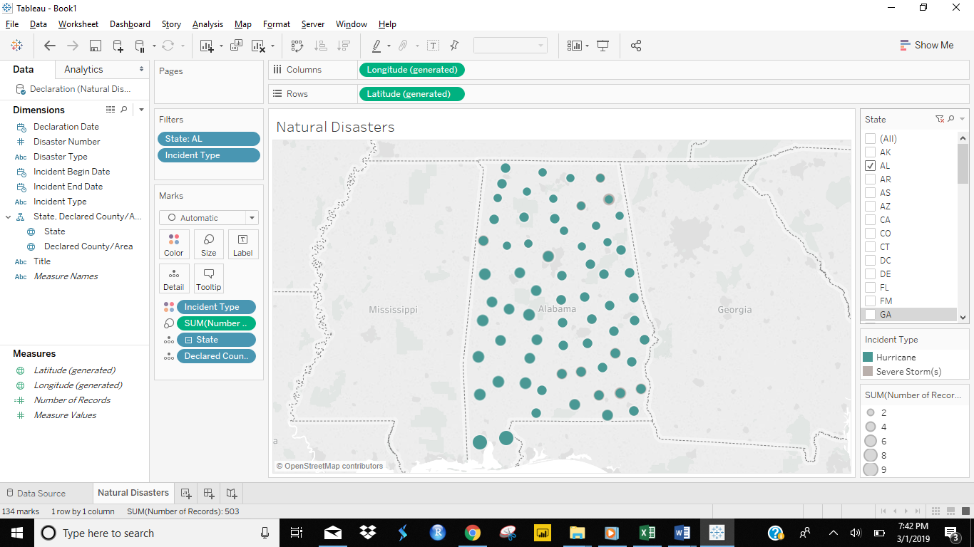

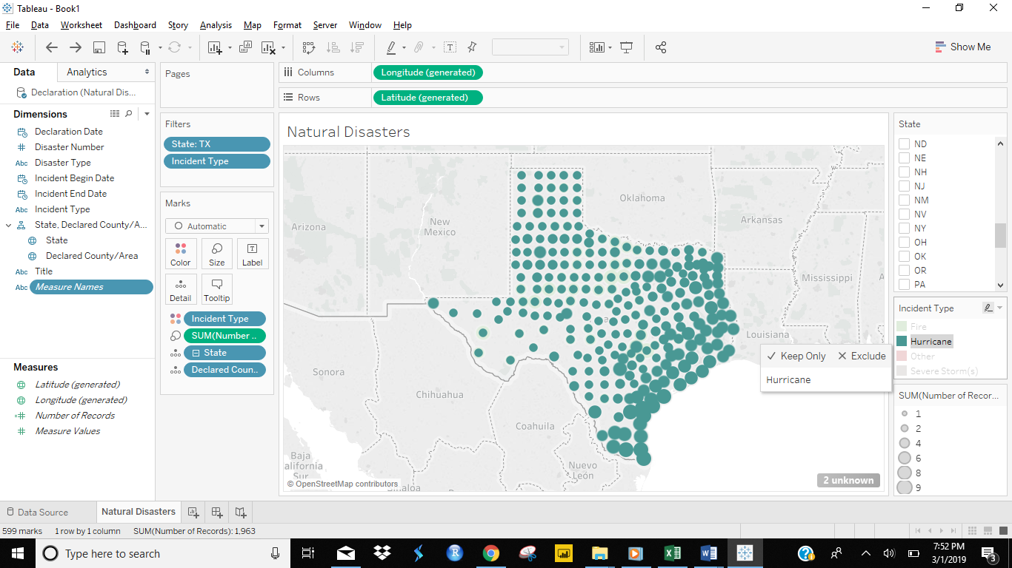

Alaska and Hawaii have been removed them from filter. Also, I visually encoded different disasters using Color and encoded number of disaster incidents/Bin a county using Size.

**The below screen displays ‘Refineries’ and ‘Disasters’ on map**

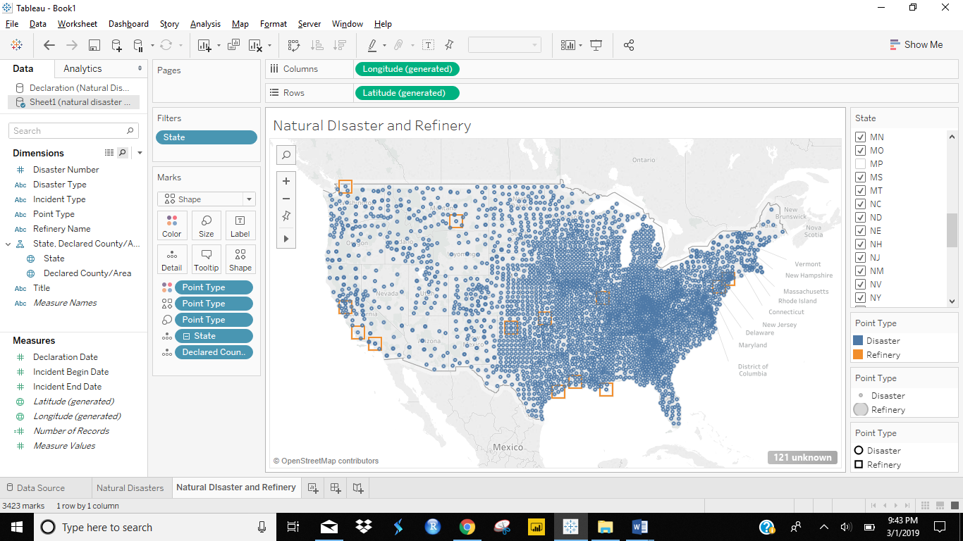

**The below figure displays disasters and refineries in new color and shape**

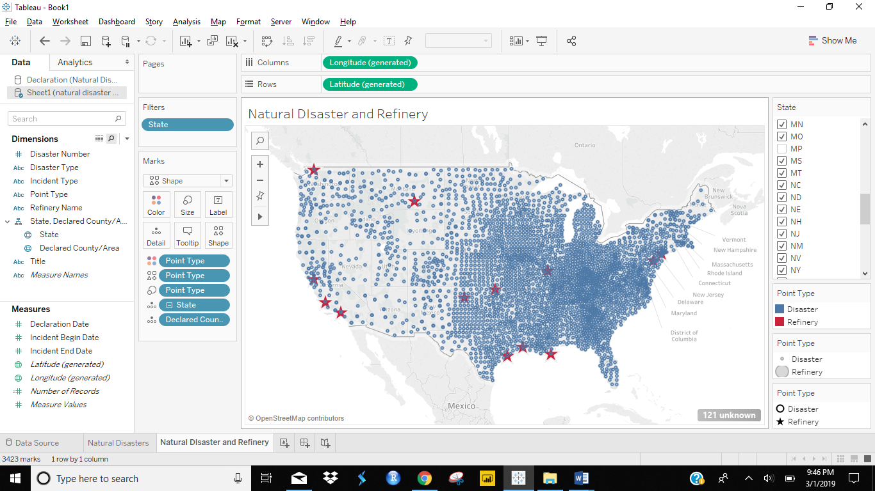

The Energy Company has refineries below states which can be viewed in below figures:

**California, Illinois, Louisiana, Montana, New Jersey, Oklahoma, Pennsylvania, Texas, Washington**

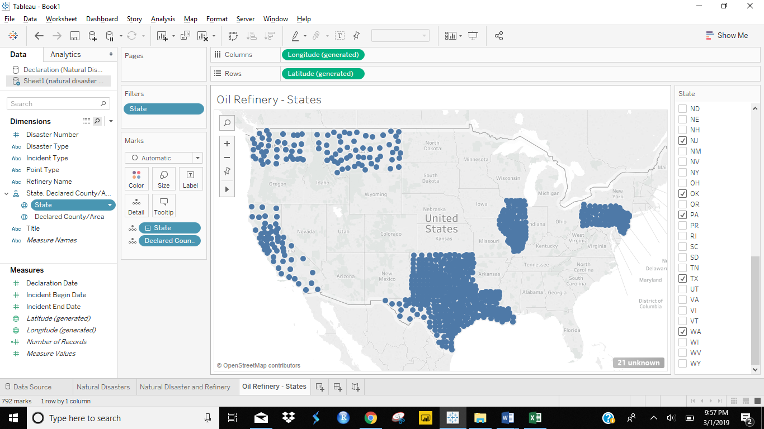

**The below figure displays disasters (with different colors) and oil refineries**

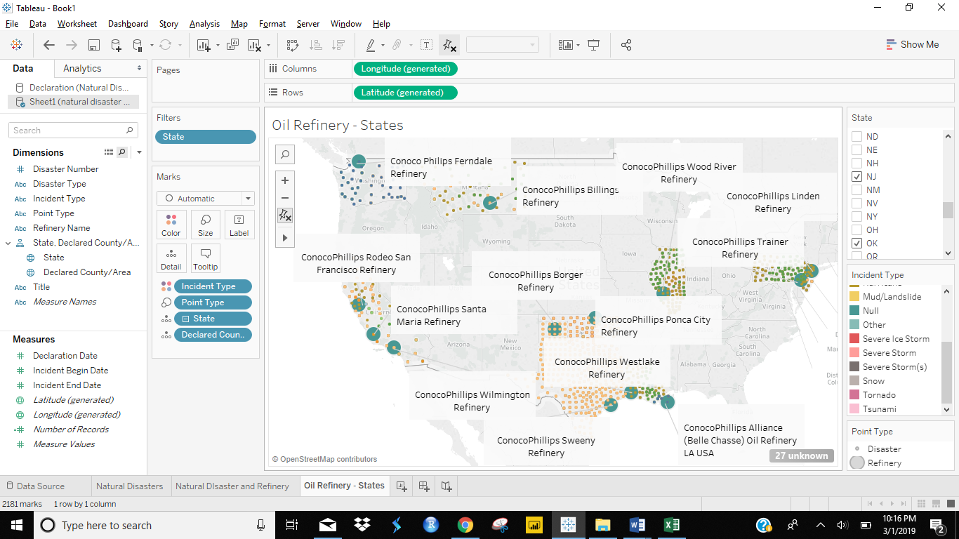

There are least 2 states list all disasters that are impacting that state

Texas: Fire, hurricane, Severe Storms

Montana: Fire, Flood, Hurricane, Severe Storm

The top 4 disasters impacting refinery locations:

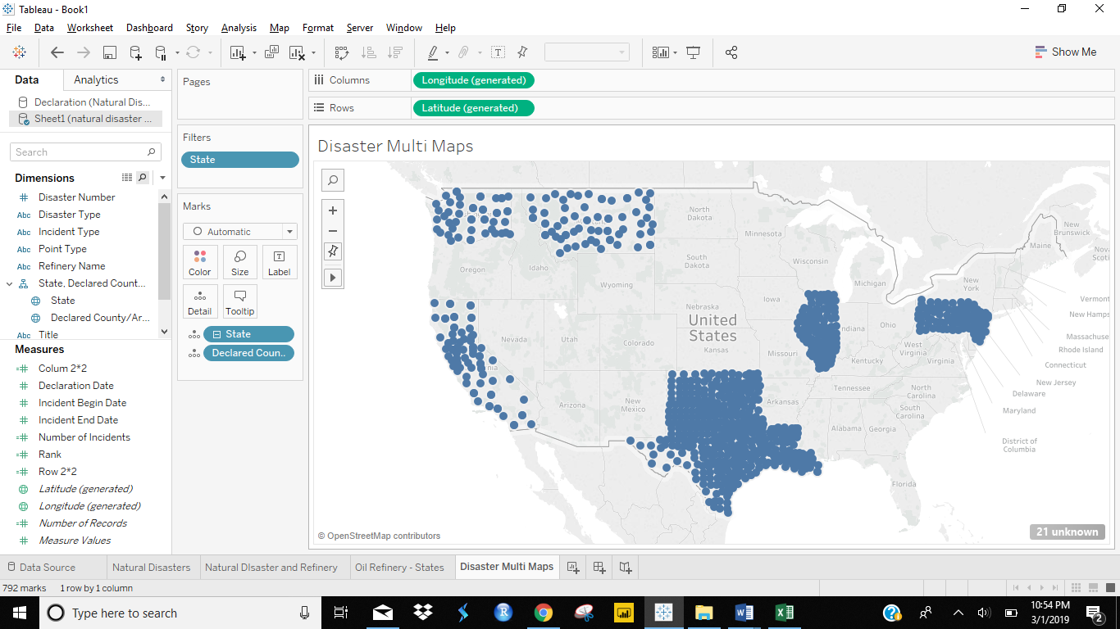

Hurricane is most occurring disaster

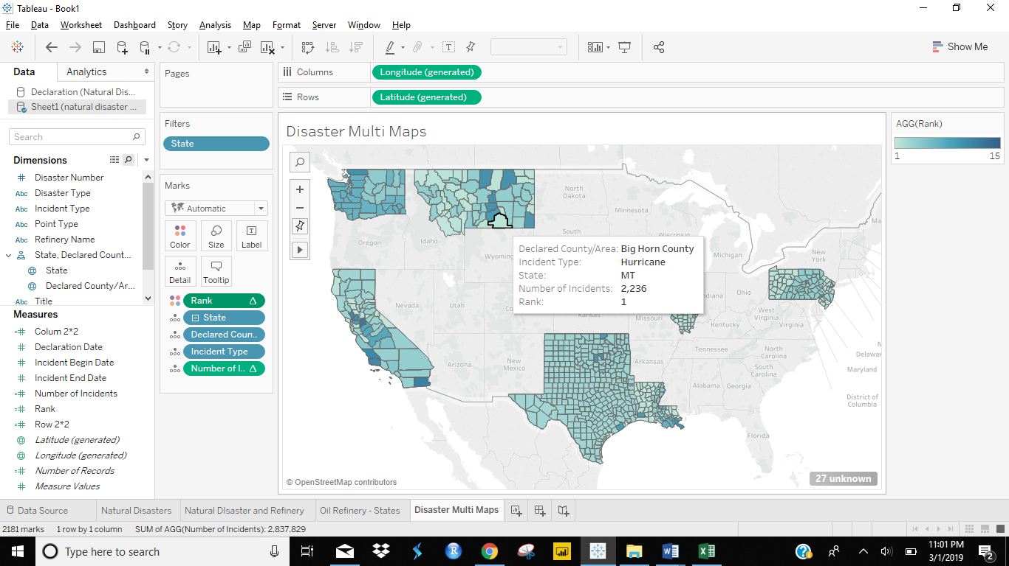

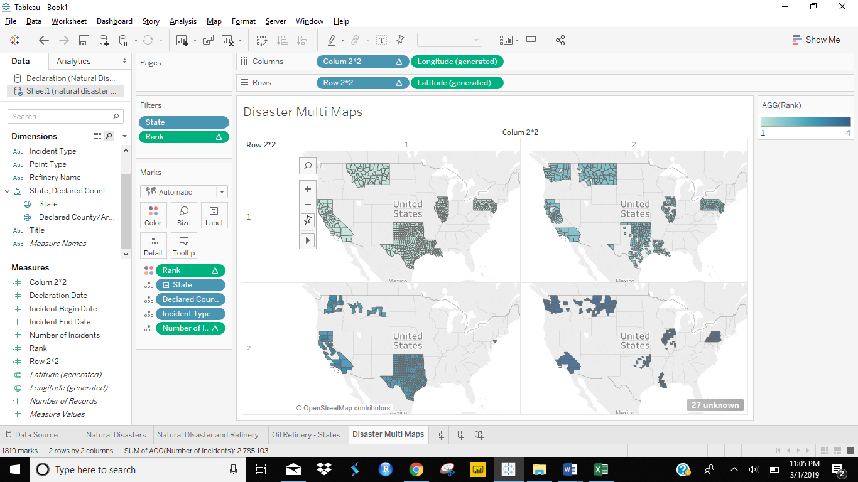

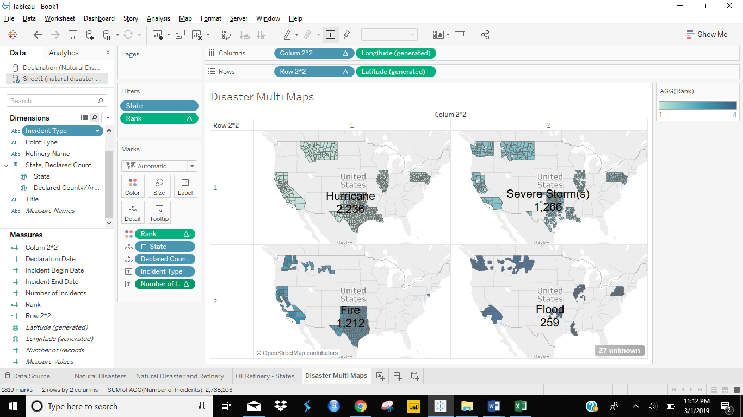

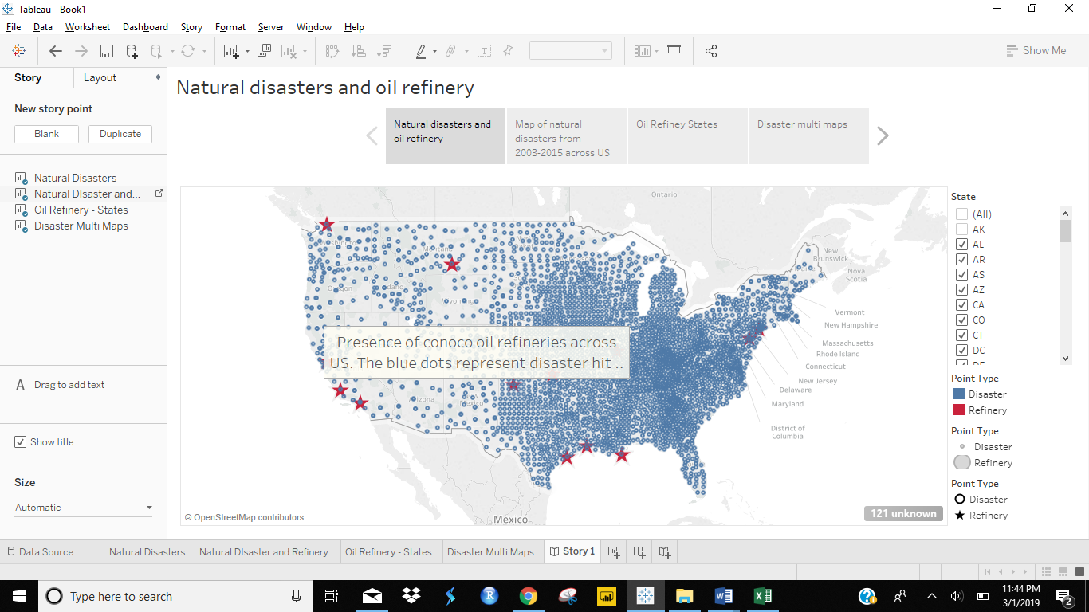

Disaster and Oil Refinery Story

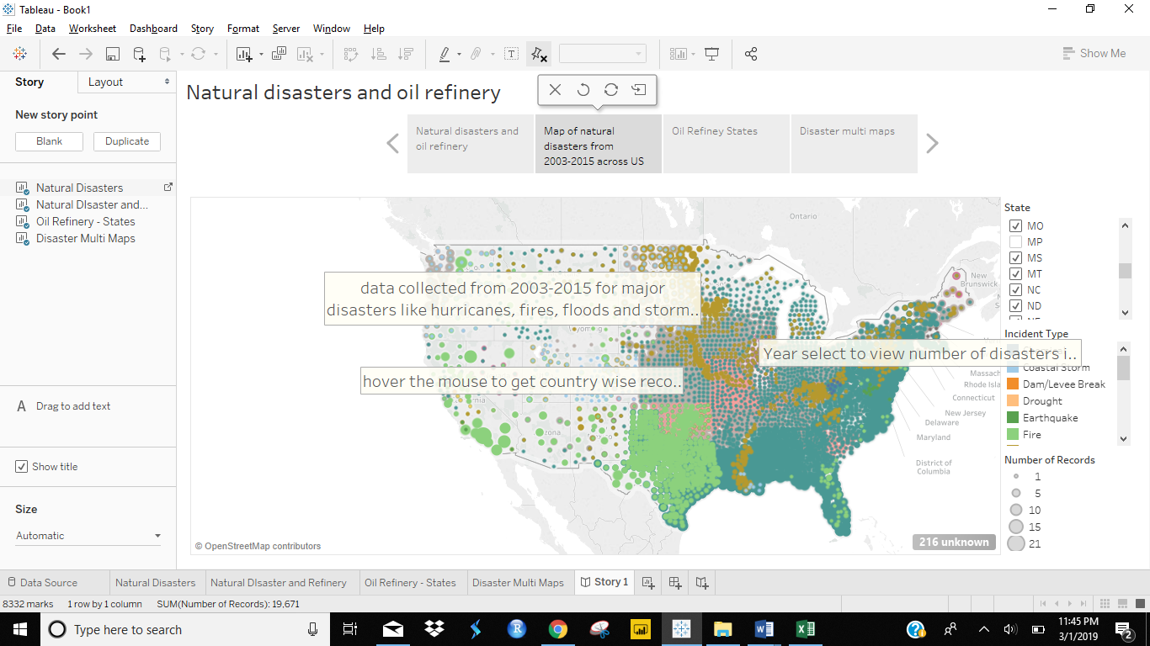

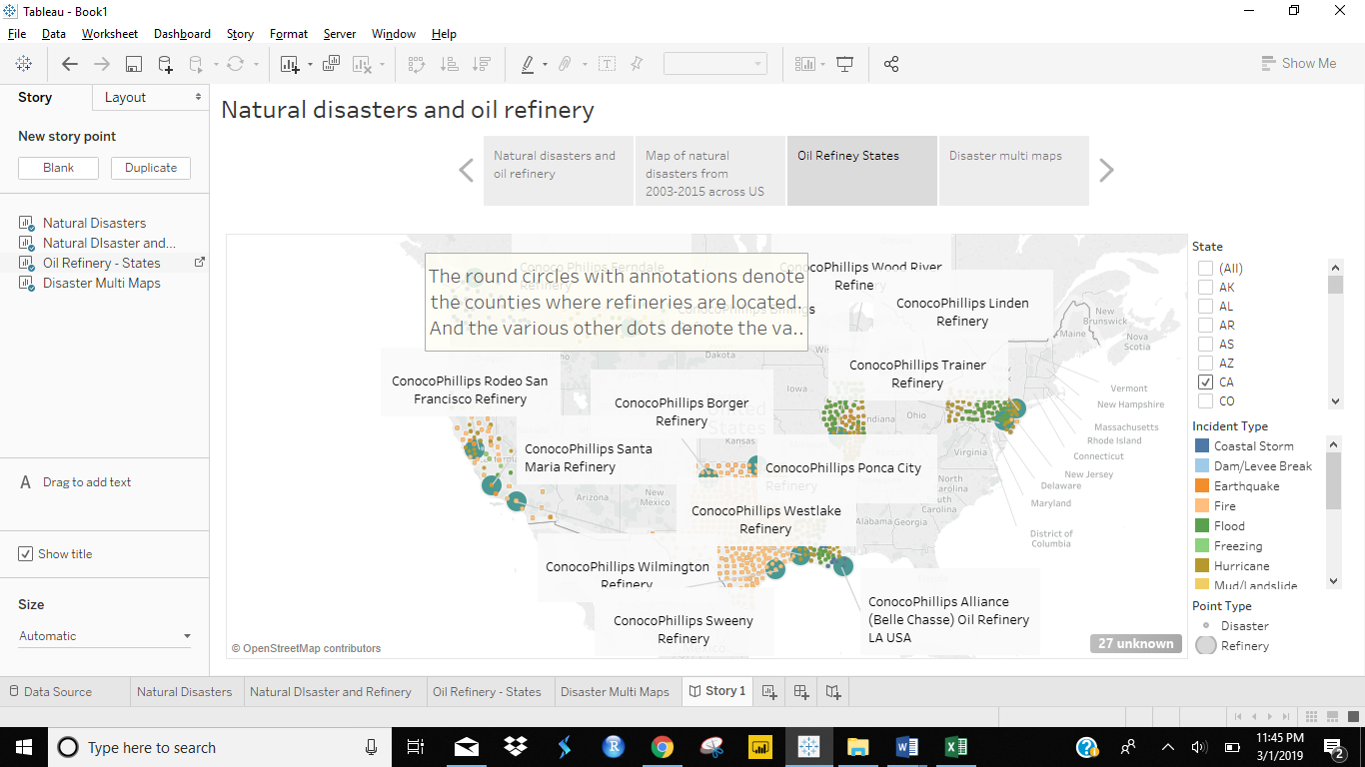

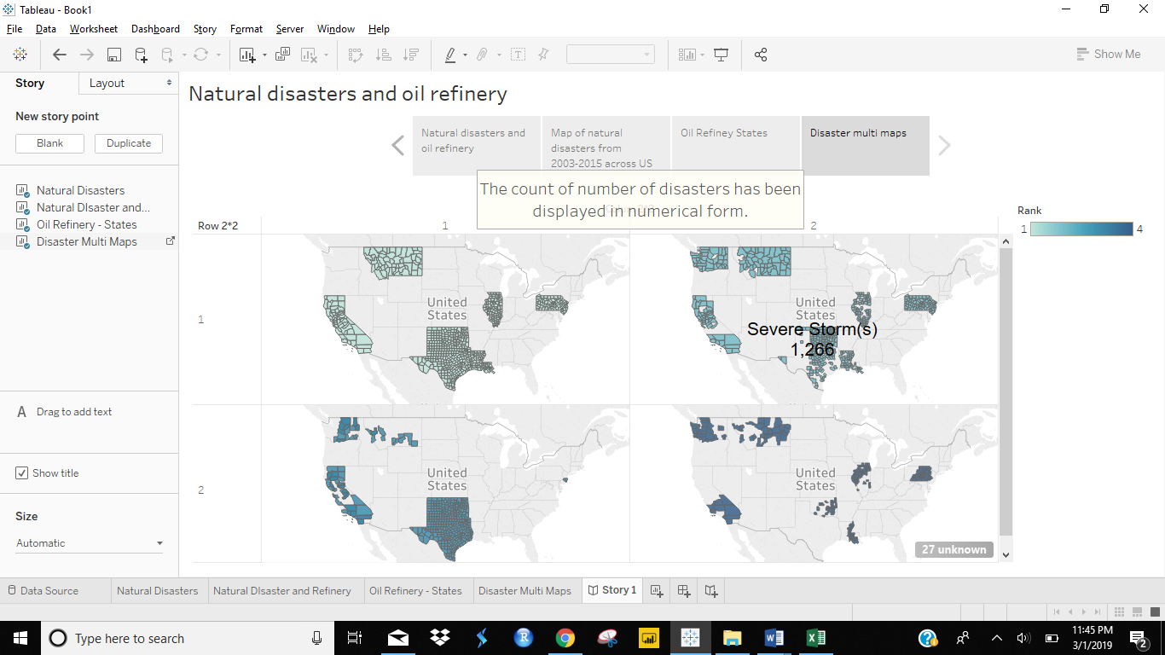

# Conclusion

In above figure, we have refinery data along with disaster data. After comparing these two data, we can observe the direct relationship between refineries and disasters have taken place.

This is the rhetoric being used which is narrative in nature.